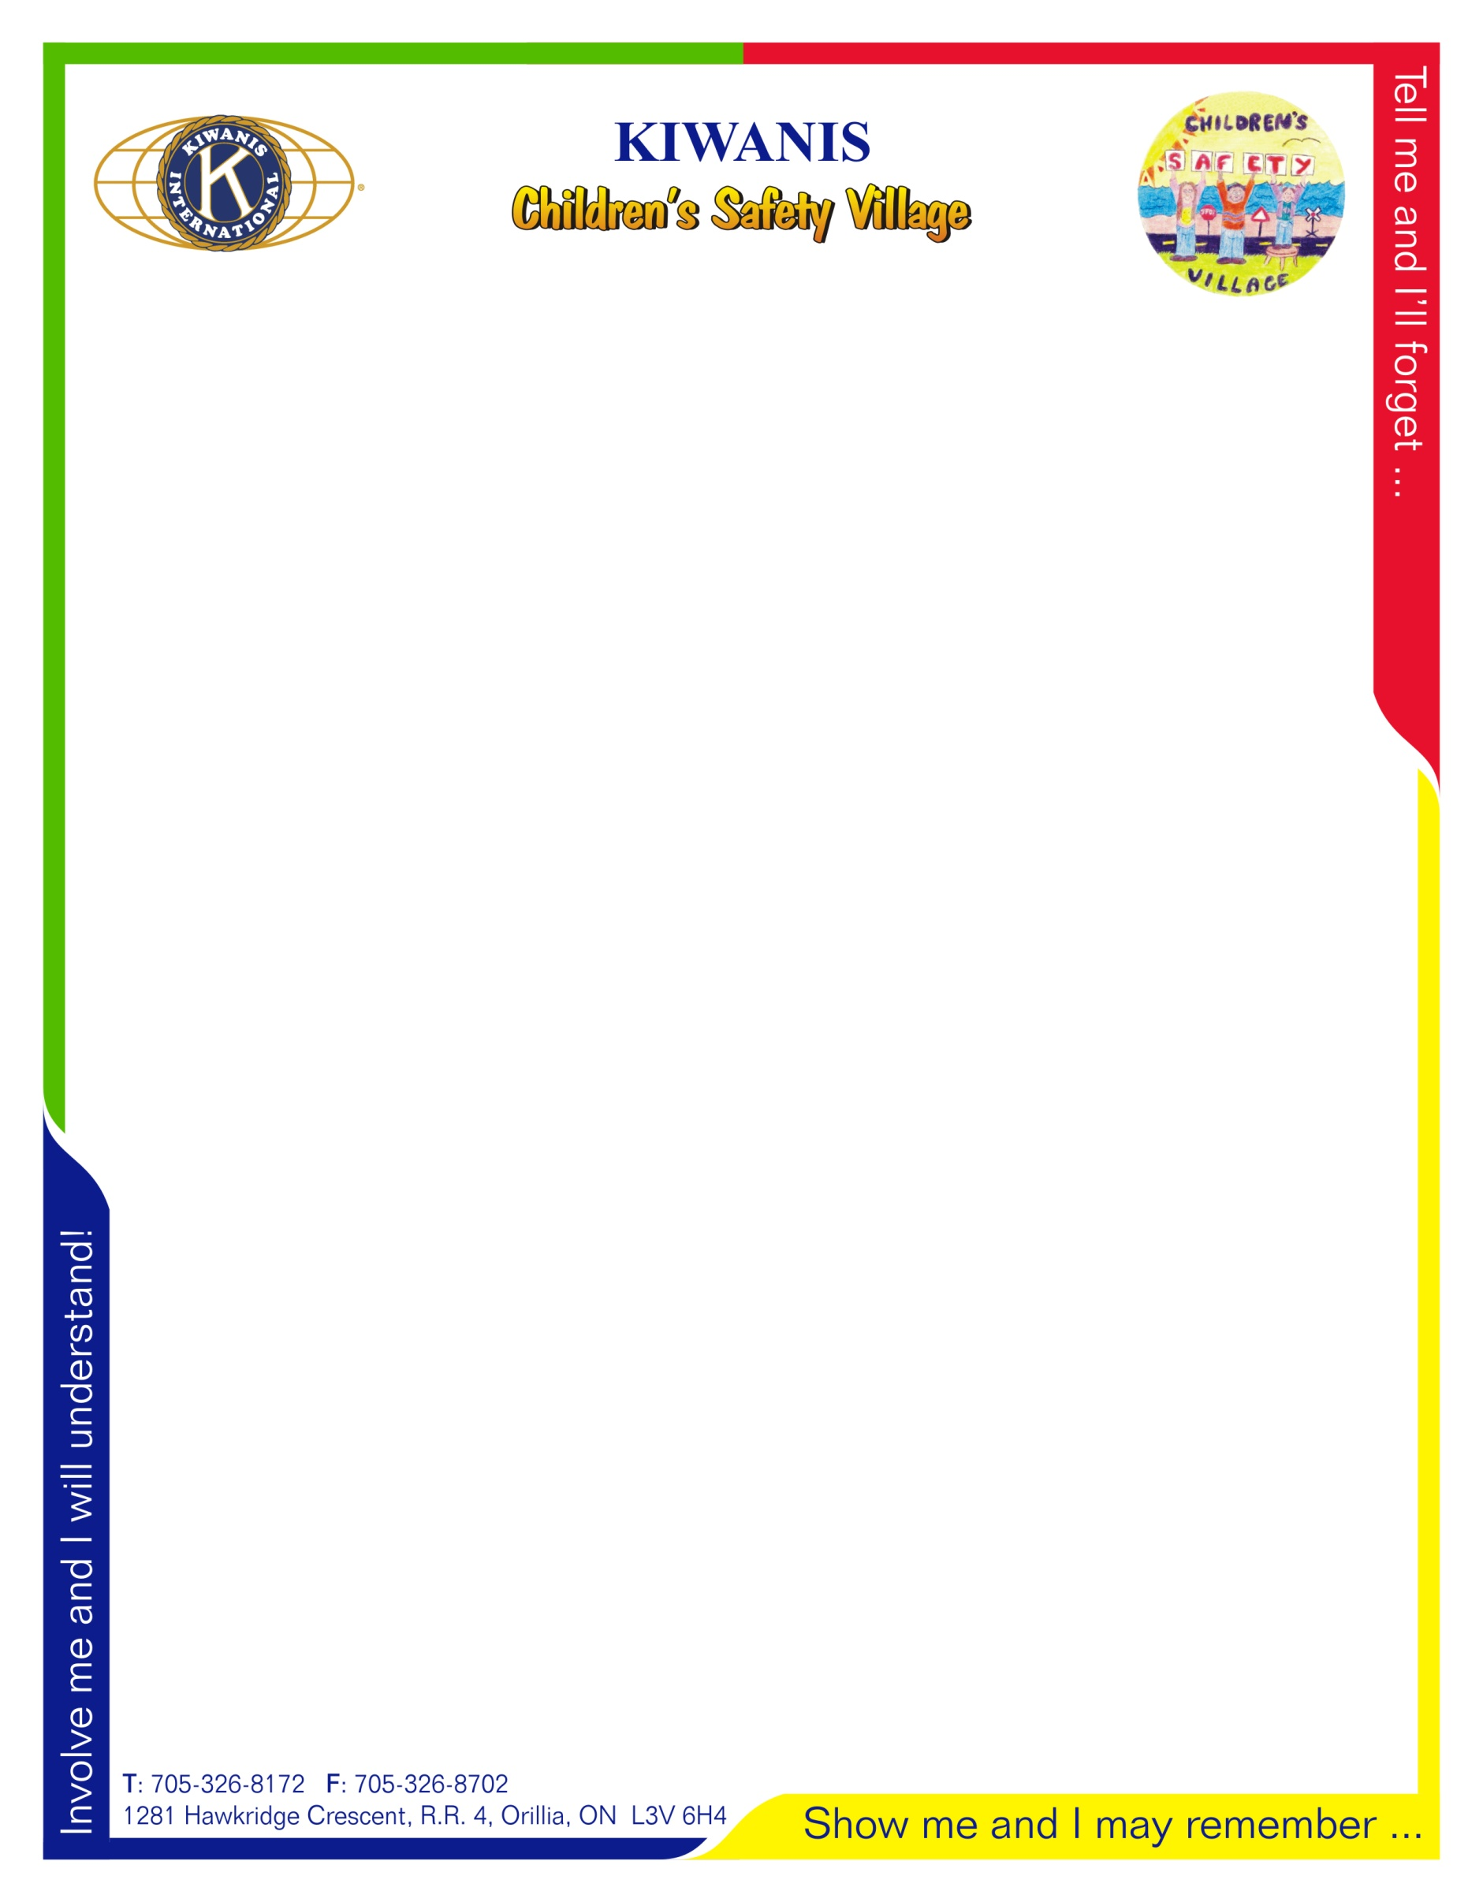

**Kiwanis Children’s Safety Village**

**Lesson Plan Overview**

***Ramara Fire***

* Kindergarten JK & SK -At this incipient stage of learning, we try to address the identification of hazards and how to react to certain fire situations. Through video, storytelling and some practical involvement, we introduce hazards in the home and the environment in which they live, stop drop and roll, crawl low under smoke, checking exit doors and community helpers.
* Grade One - At this age, we briefly review all that was learned in Kindergarten and then expand upon self-responsibility, such as reporting fires and smoke immediately. This is broken down into the individual students knowing their home address, telephone number and proper use of 911. Other discussion points are responding correctly during fire drills. Identifying exit signs and knowing two ways out of a building other than their home. This is also the age we introduce them to the Fire Safety house and we reinforce our lessons there.
* Grade Two - Again we review previous years learning and again increase the level of cognitive cooperation. These lessons are generally taught in the fire safety house but time is allotted for in the class to prepare them for the E.D.I.T.H. challenge. We start the new lessons with the importance of smoke alarms and their locations as well as our response to the smoke alarm at home. We have them practice an in-home hazard inspection, identifying different types of hazards from electrical to careless smoking and heating safety. E.D.I.T.H. Is Exit Drills In The Home and each student must design a floor plan of their home, marking all pertinent information and hand it in for judging. We issue prizes after judging is done and return all plans so that they can be exercised at home.
* Grade Three - Review all previously learned behaviours and start practicing fire safety around home heating sources and other house hazards. We also teach about flammable liquids around the home such as gas and oils. As the children become more involved in daily activities around the home, we capture the fire safety around that activity. A lot of this is again captured in the Fire Safety House and we also start to focus on Practicing outdoor fire safety and fire as a tool not a toy.
* Grade Four - This is the students last year of exposure to the Fire Safety House and on top of quick review of all that was previously learned we start to focus on a more adult aspect and ability to cook or care for others. We discuss helping an adult cook in the kitchen, identifying safe ways out of buildings, i.e. at a mall or a high-rise fire. We also get into extinguishers and understanding their use as well as smoke tents and keeping smoke out of a room.
* Grade Seven - We give the grade fives and sixes these years off as it works for the number of personnel that we have to employ our teaching model and this curriculum all in one day. By the time these students reach grade seven, they have retained our fire safety lessons of past and can easily reiterate it years later. We now introduce the grade sevens to live fire and extinguishers. We train each student in proper extinguisher selection, use and maintenance. At the end of the in-class power point and interactive lesson, we head outside to allow each student to identify the correct extinguisher for the fire that is presented to them and in turn extinguish the fire.
* Grade Eight - With special permission from the Red Cross, we are able to offer these young adults a full Emergency CPR and First Aid training session. All Materials for the course are provided by Stepan Canada. A great corporate citizen in our community.